Scenario 1: It is player Bora’s turn. During his turn, game randomly generates a power-up. He moves and gets the power-up.
Scenario 2: Player Kıvanç opens the game, clicks on the load game, loads one saved game with arrow keys and starts playing.
Scenario 3: It’s player Eren’s turn. He shoots and kills Ali. Because all other players are dead, game ends and a victory screen pops up.

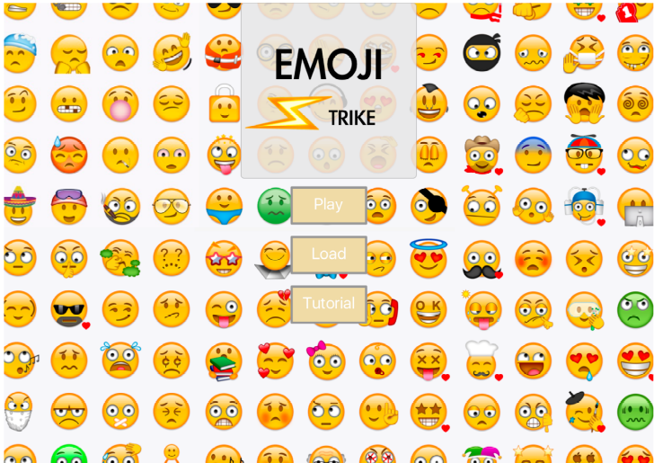
On this screen, the user can press three buttons; play, load and tutorial. Pressing play button opens the map select screen, load button opens saved games screen and tutorial button starts a tutorial.
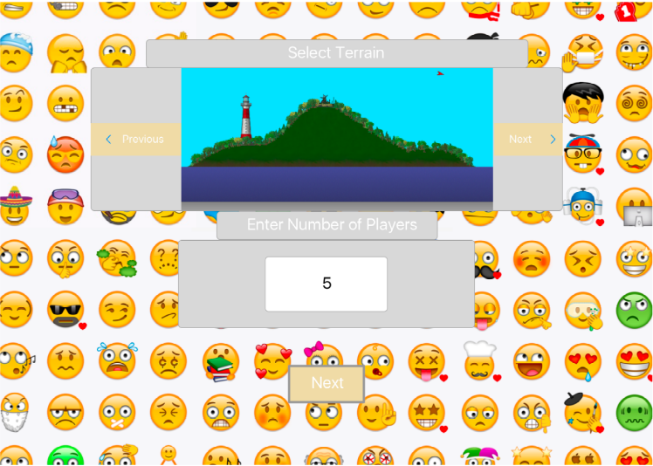
On the map selection screen player can select a terrain and determines the number of players. Next button opens the player selection screen.
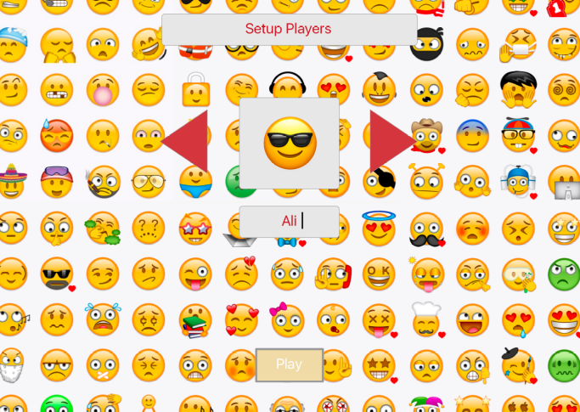
On the player selection screen, user can determine the players’ names and emojis. Play button starts the game.
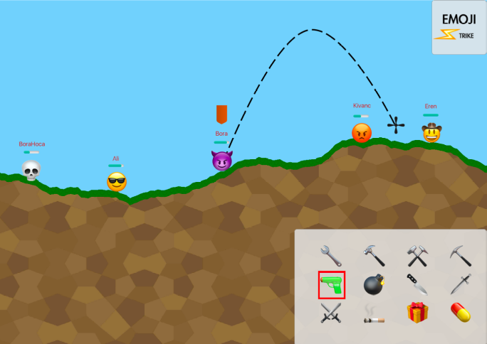
The game screen is where the users play the game.
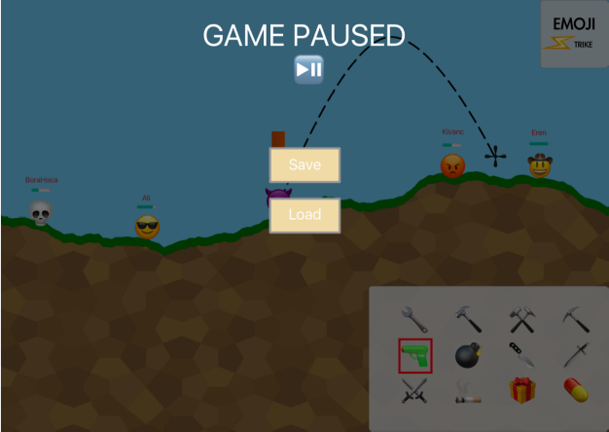
On the pause screen player can save the game. Pressing p opens and closes the pause screen.

